Contemporary Physics

Physics 2303 – Dr. Amena Khan

Dr. Amena Khan – [khan@utdallas.edu](mailto:khan@utdallas.edu) – office hours 10-11 am Tu-Th

Mastering Physics Code PHYS2303F2017; 3 major exams as well as pop quizzes.

Exam 1: 20%, Exam 2: 20%, Final: 30%, Quizzes: 20%, Homework: 10%; Mastering Physics Primer +1%

Late homework loses 10% per day. Two lowest quiz grades will be dropped. No makeup quizzes.

Exam 1: Ch. 33-35 (Sept. 26); Exam 2: Ch. 36-38 (Oct. 31); Final: 39, 41, 43-44 (Exam Week)

Final exam is cumulative. Exam dates are subject to change. Exams 1 and 2 will be returned. Physics tutoring will be provided by the TA. No specific tutoring for contemporary physics.

Exams will be similar to the Mastering Physics homework.

# Optics

The Nature of Light

Optics is a study of the behavior of light and other electromagnetic waves and their interaction with matter. It helps us form an understanding of the visible world. We will learn to appreciate the design of optical devices that use and detect light.

Light is both a particle and a wave. They do not contradict each other experimentally. Absorption and emission require a particle approach. Phenomena of diffraction and interference are a result of its wave-like properties.

As of 1983, the speed of light in a vacuum has been determined to be 299,792,458 m/s based on the vibration of the cesium atom. This is a fundamental concept of nature. This is fundamental to the definition for the meter.

Fundamental sources of all electromagnetic radiation are electric charges in accelerated motion.

The visible light range is 700 nm to 400 nm.

*The two types of waves are transverse and longitudinal waves.* “Slinky” is not an acceptable answer.

Interesting note: a hydrogen atom has a radius of about one angstrom.

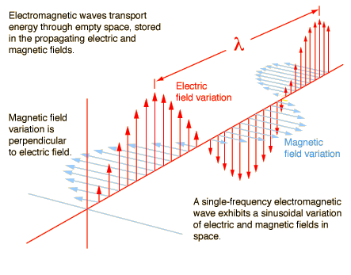Electromagnetic waves need no medium.

The energy of a wave is proportional to the square of the amplitude of the wave.

When wave fronts are spherical, the rays radiate from the center of the sphere. When they are planar, the rays are perpendicular to the wave front and parallel to each other. We will use the concept of *rays* (lines parallel to the waves) to discuss geometric (Newtonian) optics. We will use waves to discuss physical optics.

Specular reflection occurs on a smooth surface at a definite angle, such as on polished metals or mirrors. Diffuse reflection occurs on a rough surface and scatters the light rays.

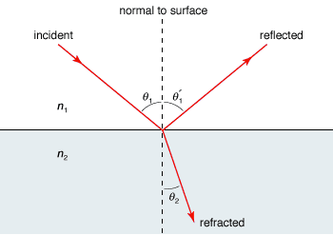Rays of light travel in straight lines. If they are traveling at an angle and changing from a less dense medium to a denser medium, light bends.

### **Law of Reflection**

The incident, normal, and reflection all lie in the same plane.

### Index of Refraction

The ratio of the speed of light in a vacuum, , to the speed of light in an optical material, . It is denoted by .

Index of refraction of air at STP is .

### Snell’s Law

For two different given media,

Light passing into a material of greater index of refraction will be bent *towards* the normal.

Light passing into a material of lesser index of refraction will be bent *away from* the normal.

When we talk about the index of refraction of light, we specifically talk about the index of refraction of yellow sodium light, . Frequency of the light does not change, so the wavelength changes in response to the drop in speed. Derive from these relationships.

**Example 33.1**

In fig. 33.10, material *a* is water, material *b* is a glass with . If the ray makes an angle of 60° with the normal, find the directions of the reflected and refracted rays.

### Principle of Reversibility of Light

Light will follow exactly the same path is its direction of travel is reversed.

### Total Internal Reflection

Assume you have two materials *a* and *b*. . Light radiates upward from a point source in *a*. From Snell’s Law:

Therefore, the refracted ray is bent away from the normal. The value of for which the refracted ray emerges tangent to the surface is the critical angle.

One of the key applications is fiber optics, telescope lenses and prisms.

### Dispersion

Speed of light in a material is wavelength dependent, so index of refraction is a function of wavelength.

### Scattering of Light in the Atmosphere

Scattering intensity; Rayleigh Scattering:

The sky is blue because of Rayleigh scattering. It’s not violet because our eyes are better at detecting blue. The ocean is blue due to scattering as well. It also exhibits Raman Scattering.

## C:\Users\Cody\AppData\Local\Microsoft\Windows\INetCache\Content.Word\mirror rays.pngGeometric Optics

### Point Objects

Real & Virtual Images

Real Image – Light rays pass through the image point

Virtual Image – Light rays only appear to pass through the image point.

### Reflection at a Spherical Surface

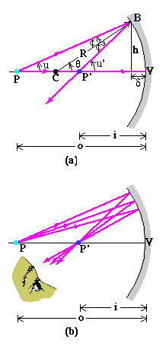Definitions:

Math Theorem: The external angle of a triangle equals the sum of the two opposite interior angles.

Or, by the diagram in the notes…

All the normal lines of reflection will pass through point .

Image formation by a spherical mirror:

If are small, , then . If is really small, .

Using the approximations…

For a concave mirror, . Images will be real or virtual.

For a convex mirror, Images will be virtual.

Sign rules:

1. Object distance: when the object is on the same side of the mirror as the incoming light, the object distance is positive
2. (See slides)

When object distance is very large (i.e. stars), . Therefore,

Mirror aberrations are errors in the parabola that cause the focus to change.

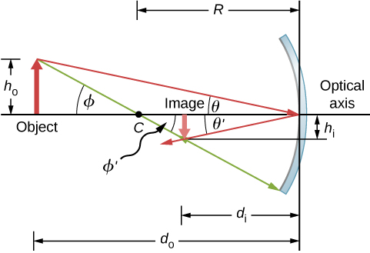Lateral magnification:

Ex. 34.1: Object at 10 cm from a concave mirror forms an image 3.0 m from the mirror. What is the radius of curvature?

If the height of the object is 5 mm, what would the image height be?

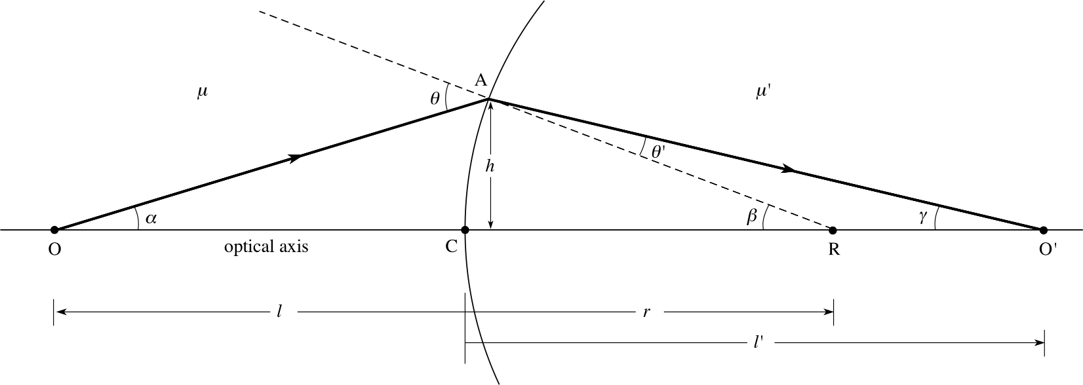For the convex image, we see a virtual image behind the mirror. They will always be upright and virtual.

### Refraction at a Spherical Surface

Refraction for a spherical surface:

### The Cassegrainian Telescope

Distance from detector to primary mirror vertex to detector is 15 cm. Distance from to is 2.5 m.

## Refraction at a Spherical Surface

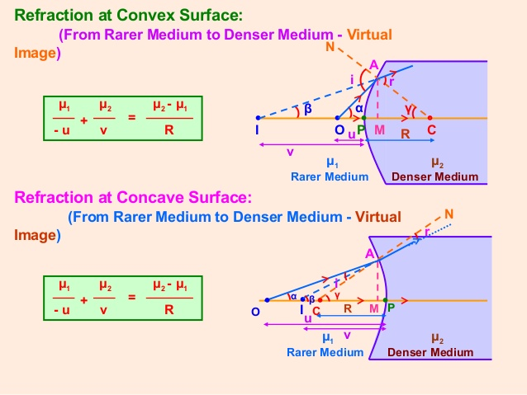A cylindrical glass rod has an index of refraction 1.52. One end is ground to a hemispherical surface with a radius of 2.00 cm. Find the image distance of a point object on the axis of the rod 8 cm to the left of the vertex.

Refraction at a spherical surface:

Lateral magnification:

is where you start, is where you end.

## Optical Lenses

Lenses can be thought of as a set of prisms that either diverge or converge light.

The thin lens approximation lets you think of the lens as a line and work only with the foci.

Much like spherical mirrors, you only need two rays to locate the image.

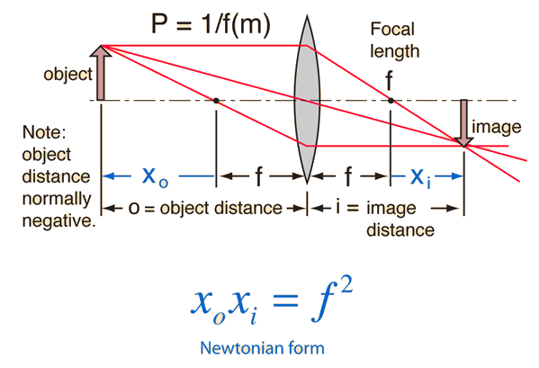Lens formula and magnification are the same as with mirrors.

### The Lensmaker’s Equation

Assume thickness of lens, , is very small.

This condenses to the Lensmaker’s Equation:

…where is the index of refraction of the glass.

When the center of curvature of the first surface is on the same side as the incoming light, the radius of curvature is negative, e. g. a diverging lens. Otherwise, e.g. for a converging lens, it is positive.

Example 34.8 – Double Convex Lens

### Sign Rules & Image Formation

#### Object Distance

When object is on the same side of the lens as the incoming light, object distance is positive.

#### Image Distance

When image is on the same side of the lens as the outgoing light, image distance is positive.

#### Radius of Curvature

Converging: when center of curvature of first surface is on the same side as the *outgoing* light, radius is *positive*.

Diverging: when center of curvature of first surface is on the same side as the *incoming* light, radius is *negative*.

## Light as a Wave

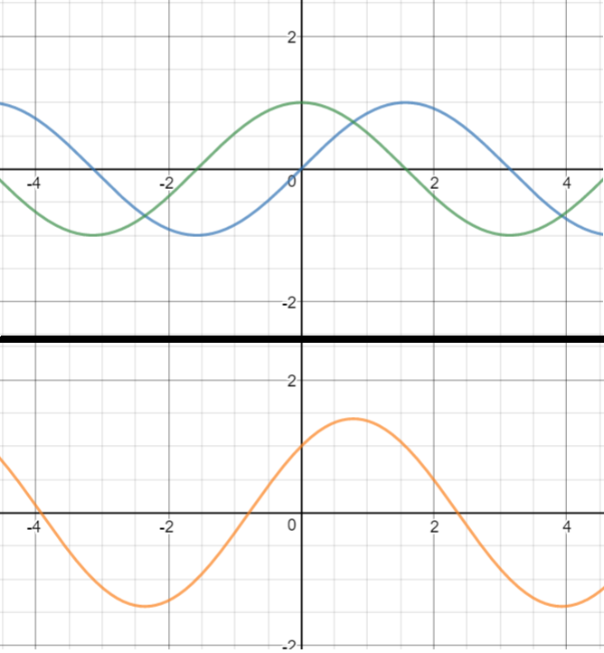Waves can “stack” or “cancel” each other based on their superposition. This is called constructive or destructive interference, respectively.

Coherent waves are the same frequency, same wavelength, and same phase. We’ll mostly analyze these.

[Desmos Interactive Interference Graph](https://www.desmos.com/calculator/bzai2s5oyr)